Rajalakshmi Engineeering College

CS23331-Design and Analysis of Algorithm

LAB Record

|  |  |
| --- | --- |
| **EXP.NO:1(a)** | **BASIC C PROGRAMMING-PRACTICE** |
| **DATE:** |

**QUESTION:**

Given two numbers, write a C program to swap the given numbers.

**For example:**

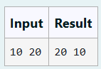

**PROGRAM:**

#include<stdio.h>

int main()

{

int a, b, t;

scanf("%d %d", &a, &b);

t=a;

a=b;

b=t;

printf("%d %d", a, b);

return 0;

}

**OUTPUT:**

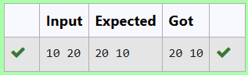

|  |  |
| --- | --- |
| **EXP.NO:1(b)** | **BASIC C PROGRAMMING-PRACTICE** |
| **DATE:** |

**QUESTION:**

Write a C program to find the eligibility of admission for a professional course based on the following criteria:

Marks in Maths >= 65

Marks in Physics >= 55

Marks in Chemistry >= 50

Or

Total in all three subjects >= 180

**Sample Test Cases**

**Test Case 1**

**Input**

70   60   80

**Output**

The candidate is eligible

**PROGRAM:**

#include<stdio.h>

int main()

{

int m,p,c;

scanf("%d %d %d",&m,&p,&c);

int t=m+p+c;

if(m>=65 && p>=55 && c>=50){

printf("The candidate is eligible");

}

else if(t>=180){

printf("The candidate is eligible");

}

else{

printf("The candidate is not eligible");

}

}

**OUTPUT:**

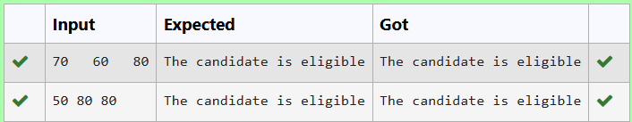

|  |  |
| --- | --- |
| **EXP.NO:1(c)** | **BASIC C PROGRAMMING-PRACTICE** |
| **DATE:** |

**QUESTION:**

Malini goes to BestSave hyper market to buy grocery items. BestSave hyper market provides 10% discount on the bill amount B when ever the bill amount B is more than Rs.2000.  
The bill amount B is passed as the input to the program. The program must print the final amount A payable by Malini.

Input Format:

The first line denotes the value of B.

Output Format:

The first line contains the value of the final payable amount A.

Example Input/Output 1:

Input:

1900

Output:

1900

Example Input/Output 2:

Input:

3000

Output:  
2700

**PROGRAM:**

#include<stdio.h>

int main(){

int c, t;

scanf("%d",&c);

if(c>2000){

t=c-(c*0.1);

}

else{

t=c;

}

printf("%d",t);

}

**OUTPUT:**

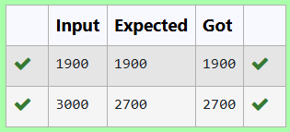

|  |  |
| --- | --- |
| **EXP.NO:1(d)** | **BASIC C PROGRAMMING-PRACTICE** |
| **DATE:** |

**QUESTION:**

Baba is very kind to beggars and every day Baba donates half of the amount he has when ever a beggar requests him. The money M left in Baba's hand is passed as the input and the number of beggars B who received the alms are passed as the input. The program must print the money Baba had in the beginning of the day.

**Input Format:**

The first line denotes the value of M.  
The second line denotes the value of B.

**Output Format:**

The first line denotes the value of money with Baba in the beginning of the day.

**Example Input/Output:**

Input:

100  
2

Output:

400

**PROGRAM:**

#include<stdio.h>

int main(){

int m, b;

scanf("%d", &m);

scanf("%d", &b);

int t=m*b;

printf("%d", t*2);

}

**OUTPUT:**

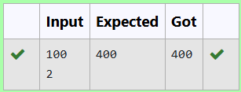

|  |  |
| --- | --- |
| **EXP.NO:1(e)** | **BASIC C PROGRAMMING-PRACTICE** |
| **DATE:** |

**QUESTION:**

The CEO of company ABC Inc wanted to encourage the employees coming on time to the office. So he announced that for every consecutive day an employee comes on time in a week (starting from Monday to Saturday), he will be awarded Rs.200 more than the previous day as "Punctuality Incentive". The incentive I for the starting day (ie on Monday) is passed as the input to the program. The number of days N an employee came on time consecutively starting from Monday is also passed as the input. The program must calculate and print the "Punctuality Incentive" P of the employee.

**Input Format:**

The first line denotes the value of I.  
The second line denotes the value of N.

**Output Format:**

The first line denotes the value of P.

**Example Input/Output:**

Input:

500  
3

Output:

2100

**PROGRAM:**

#include<stdio.h>

int main(){

int a,d;

scanf("%d",&a);

scanf("%d",&d);

int t=0;

for(int i=0;i<d;i++)

{

a=a+200;

t=t+a;

}

printf("%d",t-600);

}

**OUTPUT:**

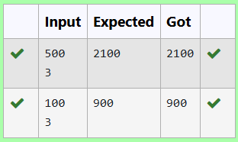

|  |  |
| --- | --- |
| **EXP.NO:1(f)** | **BASIC C PROGRAMMING-PRACTICE** |
| **DATE:** |

**QUESTION:**

Two numbers M and N are passed as the input. A number X is also passed as the input. The program must print the numbers divisible by X from N to M (inclusive of M and N).

Input Format:

The first line denotes the value of M  
The second line denotes the value of N  
The third line denotes the value of X

Output Format:  
  
Numbers divisible by X from N to M, with each number separated by a space.

Boundary Conditions:

1 <= M <= 9999999  
M < N <= 9999999  
1 <= X <= 9999

Example Input/Output 1:

Input:  
2  
40  
7

Output:  
35 28 21 14 7

**PROGRAM:**

#include<stdio.h>

int main()

{

int m,n,x;

scanf("%d\n%d\n%d",&m,&n,&x);

for(int i=n;i>=m;i--){

if(i%x==0){

printf("%d ",i);

}

}

}

**OUTPUT:**

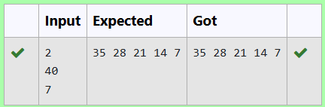

|  |  |
| --- | --- |
| **EXP.NO:1(g)** | **BASIC C PROGRAMMING-PRACTICE** |
| **DATE:** |

**QUESTION:**

Write a C program to find the quotient and reminder of given integers.

**For example:**

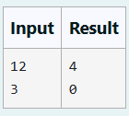

**PROGRAM:**

#include<stdio.h>

int main(){

int a, b;

scanf("%d\n%d", &a, &b);

printf("%d\n%d", a/b, a%b);

return 0;

}

**OUTPUT:**

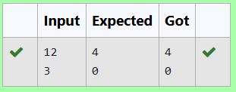

|  |  |
| --- | --- |
| **EXP.NO:1(h)** | **BASIC C PROGRAMMING-PRACTICE** |
| **DATE:** |

**QUESTION:**

Write a C program to find the biggest among the given 3 integers?

**For example:**

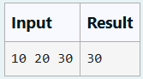

**PROGRAM:**

#include<stdio.h>

int main()

{

int a,b,c,g;

scanf("%d %d %d",&a,&b,&c);

if(a>b && a>c)

g=a;

else if(b>a && b>c)

g=b;

else

g=c;

printf("%d",g);

}

**OUTPUT:**

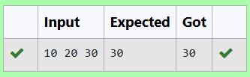

|  |  |
| --- | --- |
| **EXP.NO:1(i)** | **BASIC C PROGRAMMING-PRACTICE** |
| **DATE:** |

**QUESTION:**

Write a C program to find whether the given integer is odd or even?

**For example:**

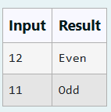

**PROGRAM:**

#include<stdio.h>

int main()

{

int n;

scanf("%d",&n);

if(n%2==0)

printf("Even");

else

printf("Odd");

}

**OUTPUT:**

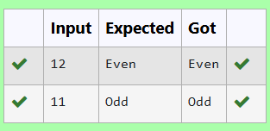

|  |  |
| --- | --- |
| **EXP.NO:1(j)** | **BASIC C PROGRAMMING-PRACTICE** |
| **DATE:** |

**QUESTION:**

Write a C program to find the factorial of given n.

**For example:**

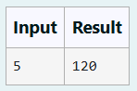

**PROGRAM:**

#include<stdio.h>

int main()

{

int n;

scanf("%d",&n);

int i,f=1;

for(i=1;i<=n;i++)

{

f*=i;

}

printf("%d",f);

}

**OUTPUT:**

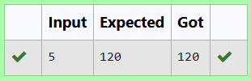

|  |  |
| --- | --- |
| **EXP.NO:1(k)** | **BASIC C PROGRAMMING-PRACTICE** |
| **DATE:** |

**QUESTION:**

Write a C program to find the sum first N natural numbers.

**For example:**

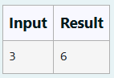

**PROGRAM:**

#include<stdio.h>

int main()

{

int n;

scanf("%d",&n);

int s=0;

for(int i=1;i<=n;i++)

{

s+=i;

}

printf("%d",s);

return 0;

}

**OUTPUT:**

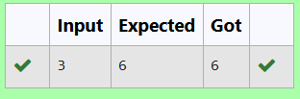

|  |  |
| --- | --- |
| **EXP.NO:1(l)** | **BASIC C PROGRAMMING-PRACTICE** |
| **DATE:** |

**QUESTION:**

Write a C program to find the Nth term in the fibonacci series.

**For example:**

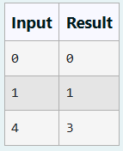

**PROGRAM:**

#include<stdio.h>

int main(){

int n,a,b,c;

scanf("%d",&n);

a=0;

b=1;

for(int i=1;i<=n;i++)

{

c=a+b;

a=b;

b=c;

}

printf("%d",a);

return 0;

}

**OUTPUT:**

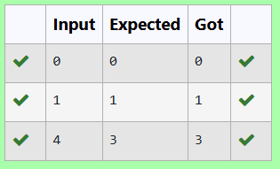

|  |  |
| --- | --- |
| **EXP.NO:1(m)** | **BASIC C PROGRAMMING-PRACTICE** |
| **DATE:** |

**QUESTION:**

Write a C program to find the power of integers.

input:

a b

output:

a^b value

**For example:**

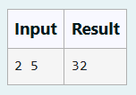

**PROGRAM:**

#include<math.h>

#include<stdio.h>

int main()

{

int a,b;

scanf("%d %d",&a,&b);

int p=pow(a,b);

printf("%d",p);

}

**OUTPUT:**

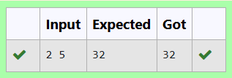

|  |  |
| --- | --- |
| **EXP.NO:1(n)** | **BASIC C PROGRAMMING-PRACTICE** |
| **DATE:** |

**QUESTION:**

Write a C program to find Whether the given integer is prime or not.

**For example:**

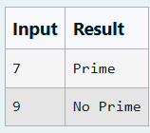

**PROGRAM:**

#include<stdio.h>

int main()

{

int n;

scanf("%d",&n);

int c=0;

for(int i=1;i<=n;i++)

{

if(n%i==0)

c++;

}

if(c==2)

{

printf("Prime");

}

else

{

printf("No Prime");

}

}

**OUTPUT:**

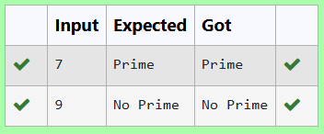

|  |  |
| --- | --- |
| **EXP.NO:1(o)** | **BASIC C PROGRAMMING-PRACTICE** |
| **DATE:** |

**QUESTION:**

Write a C program to find the reverse of the given integer?

**PROGRAM:**

#include<stdio.h>

int main(){

int n;

scanf("%d",&n);

int r=0;

while(n!=0){

r=(r*10)+(n%10);

n=n/10;

}

printf("%d",r);

}

**OUTPUT:**

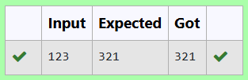

|  |  |
| --- | --- |
| **EXP.NO:2(a)** | **FINDING TIME COMPLEXITY USING COUNTER METHOD** |
| **DATE:** |

**QUESTION:**

Convert the following algorithm into a program and find its time complexity using the counter method.

void function (int n)

{

int i= 1;

int s =1; while(s <= n)

{

i++;

s += i;

}

}

Note: No need of counter increment for declarations and scanf() and count variable printf() statements.

Input:

A positive Integer n Output:

Print the value of the counter variable

**PROGRAM:**

#include<stdio.h> int main()

{

int n;

int count=0; scanf("%d",&n); int i=1; count++;

int s=1; count++; while(s<=n)

{

count++;

i++;

count++; s=s+i; count++;

}

count++; printf("%d",count); return 0;

}

**OUTPUT:**

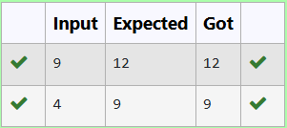

|  |  |
| --- | --- |
| **EXP.NO:2(b)** | **FINDING TIME COMPLEXITY USING COUNTER METHOD** |
| **DATE:** |

**QUESTION:**

Convert the following algorithm into a program and find its time complexity using the counter method.

void func(int n)

{

if(n==1)

{

printf("*");

}

else

{

for(int i=1; i<=n; i++)

{

for(int j=1; j<=n; j++)

{

printf("*");

printf("*"); break;

}

}

}

}

Note: No need of counter increment for declarations and scanf() and count variable printf() statements.

Input:

A positive Integer n Output:

Print the value of the counter variable

**PROGRAM:**

#include<stdio.h> int main()

{

int n; scanf("%d",&n); int c = 0;

int i; c++;

int j;

c++;

if (n == 1) { c++; c++;

} else {

for (i = 1; i <= n; i++) { c++;

for (j = 1; j <= n; j++) { c++;

c++; c++;

break;

} c++;

}

}

printf("%d", c);

}

**OUTPUT:**

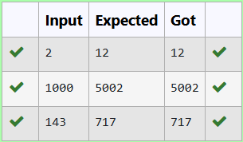

|  |  |
| --- | --- |
| **EXP.NO:2(c)** | **FINDING TIME COMPLEXITY USING COUNTER METHOD** |
| **DATE:** |

**QUESTION:**

Convert the following algorithm into a program and find its time complexity using counter method. Factor(num) {

{

for (i = 1; i <= num;++i)

{

if (num % i== 0)

{

printf("%d ", i);

}

}

}

Note: No need of counter increment for declarations and scanf() and counter variable printf() statement.

Input:

A positive Integer n Output:

Print the value of the counter variable

**PROGRAM:**

#include<stdio.h> int main()

{

int n,i; int c=0;

scanf("%d",&n);

for (i = 1; i <= n;++i)

{

c++;

if (n % i== 0)

{

c++;

// printf("%d ", i);

} c++;

} c++;

printf("%d",c); return 0;

}

**OUTPUT:**

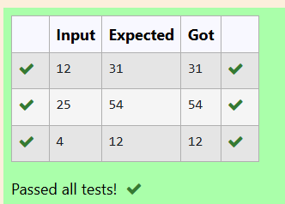

|  |  |
| --- | --- |
| **EXP.NO:2(d)** | **FINDING TIME COMPLEXITY USING COUNTER METHOD** |
| **DATE:** |

**QUESTION:**

Convert the following algorithm into a program and find its time complexity using counter method.

void function(int n)

{

int c= 0;

for(int i=n/2; i<n; i++) for(int j=1; j<n; j = 2 * j)

for(int k=1; k<n; k = k * 2) c++;

}

Note: No need of counter increment for declarations and scanf() and count variable printf() statements.

Input:

A positive Integer n Output:

Print the value of the counter variable

**PROGRAM:**

#include<stdio.h> int main()

{

int n; scanf("%d",&n); int c=0;

c++;

for(int i=n/2;i<n;i++)

{

c++;

for(int j =1;j<n;j=2*j)

{

c++;

for(int k =1;k<n;k=k*2)

{

c++; c++;

// c++;

}

c++;

}

c++;

}

c++;

printf("%d",c);

}

**OUTPUT:**

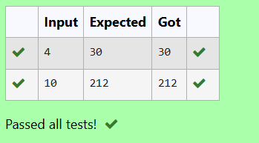

|  |  |
| --- | --- |
| **EXP.NO:2(e)** | **FINDING TIME COMPLEXITY USING COUNTER METHOD** |
| **DATE:** |

**QUESTION:**

Convert the following algorithm into a program and find its time complexity using counter method.

void reverse(int n)

{

int rev = 0, remainder; while (n != 0)

{

remainder = n % 10;

rev = rev * 10 + remainder; n/= 10;

}

print(rev);

}

**Note:** No need of counter increment for declarations and scanf() and count variable printf() statements.

**Input:**

A positive Integer n

**Output:**

Print the value of the counter variable

**PROGRAM:**

#include<stdio.h> int main()

{

int n; scanf("%d",&n); int c =0;

int rev =0,remainder; c++;

while(n!=0)

{c++;

remainder = n % 10; c++;

rev = rev * 10 + remainder; c++;

n/= 10; c++;

}

c++;

//print(rev); c++;

printf("%d",c);

}

**OUTPUT:**

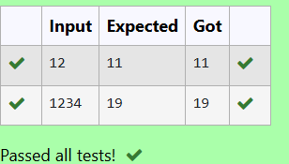

|  |  |
| --- | --- |
| **EXP.NO:3(a)** | **DIVIDE AND CONQUER** |
| **DATE:** |

**PROBLEM STATEMENT:**

Given an array of 1s and 0s this has all 1s first followed by all 0s. Aim is to find the number of 0s. Write a program using Divide and Conquer to Count the number of zeroes in the given array.

Input Format

First Line Contains Integer m – Size of array

Next m lines Contains m numbers – Elements of an array Output Format

First Line Contains Integer – Number of zeroes present in the given array.

**PROGRAM:**

#include <stdio.h> int main() {

int m, i; scanf("%d", &m); int arr[m];

for(i = 0; i < m; i++) { scanf("%d", &arr[i]);

}

int low = 0, high = m - 1, mid, firstZeroIndex = -1; while(low <= high) {

mid = low + (high - low) / 2;

if ((mid == 0 || arr[mid - 1] == 1) && arr[mid] == 0) { firstZeroIndex = mid;

break;

}

if (arr[mid] == 1) { low = mid + 1;

} else { high = mid - 1;

}

}

if (firstZeroIndex == -1) {

printf("0\n");

} else {

printf("%d\n", m - firstZeroIndex);

}

return 0;

}

**OUTPUT:**

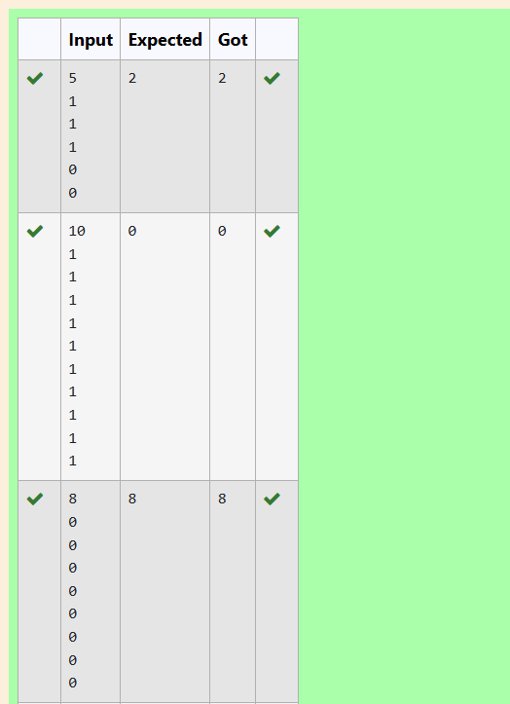

|  |  |
| --- | --- |
| **EXP.NO:3(b)** | **DIVIDE AND CONQUER** |
| **DATE:** |

**PROBLEM STATEMENT:**

Given an array nums of size n, return *the majority element*.

The majority element is the element that appears more than ⌊n / 2⌋ times. You may assume that the majority element always exists in the array.

Example 1:

Input: nums = [3,2,3] Output: 3

Example 2:

Input: nums = [2,2,1,1,1,2,2] Output: 2

Constraints:

n == nums.length 1 <= n <= 5 * 104

-231 <= nums[i] <= 231 – 1

**PROGRAM:**

#include <stdio.h>

int main() { int n;

scanf("%d", &n); int nums[n];

for (int i = 0; i < n; i++) { scanf("%d", &nums[i]);

}

int count = 0;

int candidate = 0;

for (int i = 0; i < n; i++) { if (count == 0) {

candidate = nums[i];

}

if (nums[i] == candidate) { count++;

} else {

count--;

}

}

printf("%d\n", candidate); return 0;

}

**OUTPUT:**

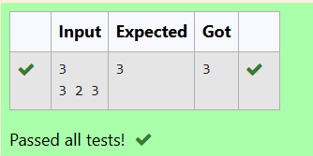

|  |  |
| --- | --- |
| **EXP.NO:3(c)** | **DIVIDE AND CONQUER** |
| **DATE:** |

**PROBLEM STATEMENT:**

Given a sorted array and a value x, the floor of x is the largest element in array smaller than or equal to x. Write divide and conquer algorithm to find floor of x.

Input Format

First Line Contains Integer n – Size of array

Next n lines Contains n numbers – Elements of an array Last Line Contains Integer x – Value for x

Output Format

First Line Contains Integer – Floor value for x

**PROGRAM:**

#include <stdio.h> int main() {

int n, x; scanf("%d", &n); int arr[n];

for (int i = 0; i < n; i++) { scanf("%d", &arr[i]);

}

scanf("%d", &x);

int left = 0, right = n - 1; int floor = -1;

while (left <= right) {

int mid = left + (right - left) / 2; if (arr[mid] == x) {

floor = arr[mid]; break;

}

if (arr[mid] < x) {

floor = arr[mid]; left = mid + 1;

}

else {

right = mid - 1;

}

}

if (floor != -1) { printf("%d\n", floor);

} else {

printf("No floor value found for %d in the array.\n", x);

}

return 0;

}

**OUTPUT:**

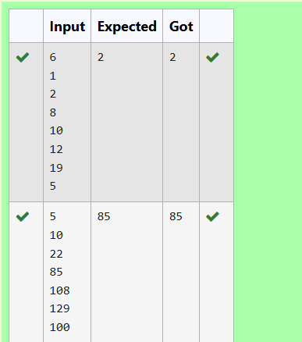

|  |  |
| --- | --- |
| **EXP.NO:3(d)** | **DIVIDE AND CONQUER** |
| **DATE:** |

**PROBLEM STATEMENT:**

Given a sorted array of integers say arr[] and a number x. Write a recursive program using divide and conquer strategy to check if there exist two elements in the array whose sum = x. If there exist such two elements then return the numbers, otherwise print as “No”.

Note: Write a Divide and Conquer Solution Input Format

First Line Contains Integer n – Size of array

Next n lines Contains n numbers – Elements of an array Last Line Contains Integer x – Sum Value

Output Format

First Line Contains Integer – Element1

Second Line Contains Integer – Element2 (Element 1 and Elements 2 together sums to value “x”)

**PROGRAM:**

#include <stdio.h> int main() {

int n, x; scanf("%d", &n); int arr[n];

for (int i = 0; i < n; i++) { scanf("%d", &arr[i]);

}

scanf("%d", &x);

int left = 0, right = n - 1; int found = 0;

while (left < right) {

int sum = arr[left] + arr[right]; if (sum == x) {

printf("%d\n", arr[left]);

printf("%d\n", arr[right]);

f ound = 1; break;

}

if (sum < x) { left++;

} else {

right--;

}

}

if (!found) {

printf("No\n");

}

return 0;

}

**OUTPUT:**

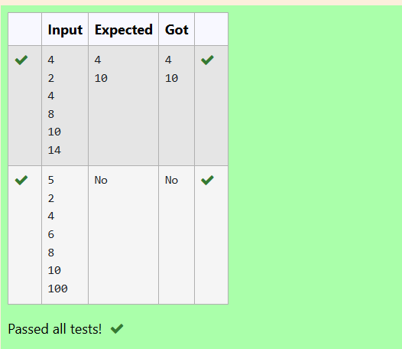

|  |  |
| --- | --- |
| **EXP.NO:3(e)** | **DIVIDE AND CONQUER** |
| **DATE:** |

**PROBLEM STATEMENT:**

Write a Program to Implement the Quick Sort Algorithm

Input Format:

The first line contains the no of elements in the list-n The next n lines contain the elements.

Output:

Sorted list of elements

**PROGRAM:**

#include <stdio.h> int main() {

int n; scanf("%d", &n); int a[n];

for (int i = 0; i < n; i++) { scanf("%d", &a[i]);

}

for (int i = 0; i < n; i++) {

for (int j = i + 1; j < n; j++) { if (a[j] < a[i]) {

int temp = a[i]; a[i] = a[j];

a[j] = temp;

}

}

}

for (int i = 0; i < n; i++) {

printf("%d ", a[i]);

}

return 0;

}

**OUTPUT:**

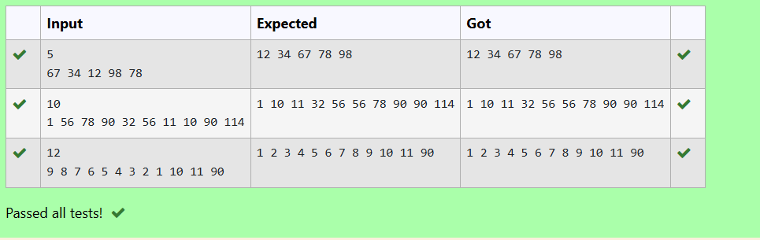

|  |  |
| --- | --- |
| **EXP.NO:4(a)** | [**1-G-COIN PROBLEM**](http://118.185.187.137/moodle/mod/quiz/view.php?id=1241) |
| **DATE:** |

**QUESTION:**

Write a program to take value V and we want to make change for V Rs, and we have infinite supply of each of the denominations in Indian currency, i.e., we have infinite supply of { 1, 2, 5, 10, 20, 50, 100, 500, 1000} valued coins/notes, what is the minimum number of coins and/or notes needed to make the change.

Input Format:

Take an integer from stdin. Output Format:

print the integer which is change of the number. Example Input :

64

Output:

4

Explanaton:

We need a 50 Rs note and a 10 Rs note and two 2 rupee coins.

**PROGRAM:**

#include <stdio.h>

int min_coins_and_notes(int V) {

int denominations[] = {1000, 500, 100, 50, 20, 10, 5, 2, 1}; int n = sizeof(denominations) / sizeof(denominations[0]); int count = 0;

for (int i = 0; i < n; i++) { if (V == 0) {

break;

}

count += V / denominations[i]; V %= denominations[i];

return count;

}

int main() { int V;

scanf("%d", &V);

printf("%d\n", min_coins_and_notes(V)); return 0;

}

**OUTPUT:**

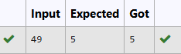

|  |  |
| --- | --- |
| **EXP.NO:4(b)** | **2-G-COOKIES PROBLEM** |
|  |
| **DATE:** |

**QUESTION:**

Assume you are an awesome parent and want to give your children some cookies. But, you should give each child at most one cookie.

Each child i has a greed factor g[i], which is the minimum size of a cookie that the child will be content with; and each cookie j has a size s[j]. If s[j] >= g[i], we can assign the cookie j to the child i, and the child i will be content. Your goal is to maximize the number of your content children and output the maximum number.

Example 1:

Input:

3

1 2 3

2

1 1

Output:

1

Explanation: You have 3 children and 2 cookies. The greed factors of 3 children are 1, 2, 3.

And even though you have 2 cookies, since their size is both 1, you could only make the child whose greed factor is 1 content.

You need to output 1. Constraints:

1 <= g.length <= 3 * 10^4

0 <= s.length <= 3 * 10^4

1 <= g[i], s[j] <= 2^31 – 1

**PROGRAM:**

#include <stdio.h> #include <stdlib.h>

int compare(const void *a, const void *b) {

return (*(int *)a - *(int *)b);

}

int findContentChildren(int g[], int gSize, int s[], int sSize) { qsort(g, gSize, sizeof(int), compare);

qsort(s, sSize, sizeof(int), compare); int childIndex = 0;

int cookieIndex = 0;

while (childIndex < gSize && cookieIndex < sSize) { if (s[cookieIndex] >= g[childIndex]) {

childIndex++;

}

cookieIndex++;

}

return childIndex;

}

int main() {

int gSize, sSize; scanf("%d", &gSize);

int *g = (int *)malloc(gSize * sizeof(int)); if (g == NULL) {

fprintf(stderr, "Memory allocation failed\n"); return 1;

}

for (int i = 0; i < gSize; i++) { scanf("%d", &g[i]);

}

scanf("%d", &sSize);

int *s = (int *)malloc(sSize * sizeof(int)); if (s == NULL) {

fprintf(stderr, "Memory allocation failed\n"); free(g);

return 1;

}

for (int i = 0; i < sSize; i++) { scanf("%d", &s[i]);

}

printf("%d\n", findContentChildren(g, gSize, s, sSize)); free(g);

free(s); return 0;

}

**OUTPUT:**



|  |  |
| --- | --- |
| **EXP.NO:4(c)** | **3-G-BURGER PROBLEM** |
| **DATE:** |

**QUESTION:**

A person needs to eat burgers. Each burger contains a count of calorie. After eating the burger, the person needs to run a distance to burn out his calories.

If he has eaten *i* burgers with c calories each, then he has to run at least *3i * c* kilometers to burn out the calories. For example, if he ate 3

burgers with the count of calorie in the order: [1, 3, 2], the kilometers he needs to run are (30 * 1)

+ (31 * 3) + (32 * 2) = 1 + 9 + 18 = 28.

But this is not the minimum, so need to try out other orders of consumption and choose the minimum value. Determine the minimum distance

he needs to run. Note: He can eat burger in any order and use an efficient sorting algorithm.Apply greedy approach to solve the problem.

Input Format

First Line contains the number of burgers

Second line contains calories of each burger which is n space-separate integers Output Format

Print: Minimum number of kilometers needed to run to burn out the calories Sample Input

3

5 10 7

Sample Output 76

**PROGRAM:**

#include <stdio.h> #include <stdlib.h> #include <limits.h>

int compareDescending(const void *a, const void *b) { return (*(int *)b - *(int *)a);

}

long long minDistance(int calories[], int n) { qsort(calories, n, sizeof(int), compareDescending); long long totalDistance = 0;

long long powerOf3 = 1; for (int i = 0; i < n; i++) {

if (powerOf3 > LLONG_MAX / calories[i]) {

fprintf(stderr, "Integer overflow detected during calculation.\n"); exit(1);

}

totalDistance += powerOf3 * calories[i]; if (powerOf3 > LLONG_MAX / 3) {

fprintf(stderr, "Integer overflow detected while computing powers of 3.\n"); exit(1);

}

powerOf3 *= 3;

}

return totalDistance;

}

int main() { int n;

if (scanf("%d", &n) != 1 || n < 0) {

fprintf(stderr, "Invalid input for number of burgers.\n"); return 1;

}

if (n == 0) { printf("0\n"); return 0;

}

int *calories = (int *)malloc(n * sizeof(int)); if (calories == NULL) {

fprintf(stderr, "Memory allocation failed\n"); return 1;

}

for (int i = 0; i < n; i++) {

if (scanf("%d", &calories[i]) != 1 || calories[i] < 0) { fprintf(stderr, "Invalid input for calorie count.\n"); free(calories);

return 1;

}

}

printf("%lld\n", minDistance(calories, n)); free(calories);

return 0;

}

**OUTPUT:**

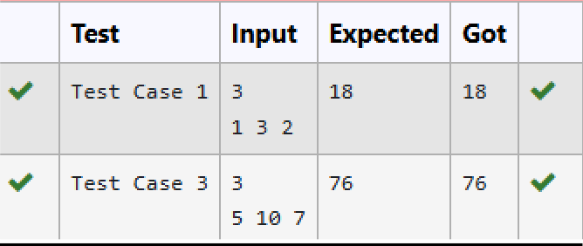

|  |  |
| --- | --- |
| **EXP.NO:4(d)** | **4-G-ARRAY SUM MAX PROBLEM** |
| **DATE:** |

**QUESTION:**

Given an array of N integer, we have to maximize the sum of arr[i] * i, where i is the index of the element (i = 0, 1, 2, ..., N).Write an algorithm based on Greedy technique with a Complexity O(nlogn).

Input Format:

First line specifies the number of elements-n The next n lines contain the array elements. Output Format:

Maximum Array Sum to be printed. Sample Input:

5

2 5 3 4 0

Sample output:

40

**PROGRAM:**

#include <stdio.h> #include <stdlib.h>

int compare(const void *a, const void *b) { return (*(int*)a - *(int*)b);

}

int main() { int n;

scanf("%d", &n);

int *arr = (int*)malloc(n * sizeof(int)); for (int i = 0; i < n; i++) {

scanf("%d", &arr[i]);

}

qsort(arrint max_sum = 0;

for (int i = 0; i < n; i++) { max_sum += arr[i] * i;

}

printf("%d\n", max_sum); free(arr);

return 0;

}

, n, sizeof(int), compare);

**OUTPUT:**

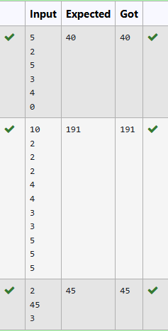

|  |  |
| --- | --- |
| **EXP.NO:4(e)** | **5-G-PRODUCT OF ARRAY ELEMENTS-MINIMUM** |
| **DATE:** |

**QUESTION:**

Given two arrays array_One[] and array_Two[] of same size N. We need to first rearrange the arrays such that the sum of the product of pairs( 1 element from each) is minimum. That is SUM (A[i] * B[i]) for all i is minimum.

**PROGRAM:**

#include <stdio.h> #include <stdlib.h>

int compare_asc(const void *a, const void *b) { return (*(int*)a - *(int*)b);

}

int compare_desc(const void *a, const void *b) { return (*(int*)b - *(int*)a);

}

int main() { int n;

scanf("%d", &n);

int *array_One = malloc(n * sizeof(int)); int *array_Two = malloc(n * sizeof(int)); for (int i = 0; i < n; i++) {

scanf("%d", &array_One[i]);

}

for (int i = 0; i < n; i++) { scanf("%d", &array_Two[i]);

}

qsort(array_One, n, sizeof(int), compare_asc); qsort(array_T)

int min_sum = 0;

for (int i = 0; i < n; i++) {

min_sum += array_One[i] * array_Two[i];

}

printf("%d\n", min_sum); free(array_One); free(array_Two);

return 0;

}

wo, n, sizeof(int), compare_desc);

**OUTPUT:**

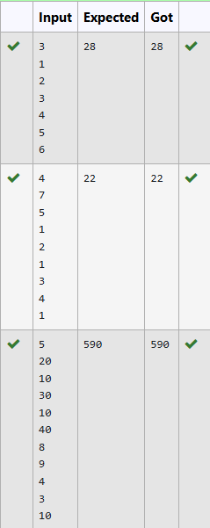

|  |  |
| --- | --- |
| **EXP.NO:5(a)** | **PLAYING WITH NUMBERS** |
| **DATE:** |

**QUESTION:**

Ram and Sita are playing with numbers by giving puzzles to each other. Now it was Ram term, so he gave Sita a positive integer ‘n’ and two numbers 1 and 3. He asked her to find the possible ways by which the number n can be represented using 1 and 3.Write any efficient algorithm to find the possible ways.

Example 1:

Input: 6 Output:6

Explanation: There are 6 ways to 6 represent number with 1 and 3

1+1+1+1+1+1

3+3

1+1+1+3

1+1+3+1

1+3+1+1

3+1+1+1

Input Format

First Line contains the number n

Output Format

Print: The number of possible ways ‘n’ can be represented using 1 and 3 Sample Input

6

Sample Output 6

**PROGRAM:**

#include <stdio.h>

long long count_ways(int n) { long long dp[n + 1];

dp[0] = 1;

if (n >= 1) {

dp[1] = 1;

}

if (n >= 2) {

dp[2] = 1;

}

if (n >= 3) {

dp[3] = 2;

}

for (int i = 4; i <= n; i++) { dp[i] = dp[i - 1] + dp[i - 3];

}

return dp[n];

}

int main() { int n;

scanf("%d", &n); printf("%lld\n", count_ways(n)); return 0;

}

**OUTPUT:**

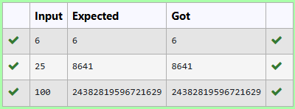

|  |  |
| --- | --- |
| **EXP.NO:5(b)** | **PLAYING WITH CHESSBOARD** |
| **DATE:** |

**QUESTION:**

Ram is given with an n*n chessboard with each cell with a monetary value. Ram stands at the (0,0), that the position of the top left white rook. He is been given a task to reach the bottom right black rook position (n-1, n-1) constrained that he needs to reach the position by traveling the maximum monetary path under the condition that he can only travel one step right or one step down the board. Help ram to achieve it by providing an efficient DP algorithm.

Example:

Input 3

1 2 4

2 3 4

8 7 1

Output:

19

Explanation:

Totally there will be 6 paths among that the optimal is Optimal path value:1+2+8+7+1=19

Input Format

First Line contains the integer n

The next n lines contain the n*n chessboard values Output Format

Print Maximum monetary value of the path

**PROGRAM:**

#include <stdio.h> #define MAX 100 int max(int a, int b) {

return (a > b) ? a : b;

}int maxMonetaryPath(int chessboard[MAX][MAX], int n) { int dp[MAX][MAX];

for (int i = 0; i < n; i++) { for (int j = 0; j < n; j++) {

dp[i][j] = 0;

}

}

dp[0][0] = chessboard[0][0]; for (int j = 1; j < n; j++) {

dp[0][j] = dp[0][j - 1] + chessboard[0][j];

}

for (int i = 1; i < n; i++) {

dp[i][0] = dp[i - 1][0] + chessboard[i][0];

}

for (int i = 1; i < n; i++) { for (int j = 1; j < n; j++) {

dp[i][j] = chessboard[i][j] + max(dp[i - 1][j], dp[i][j - 1]);

}

}

return dp[n - 1][n - 1];

}

int main() { int n;

int chessboard[MAX][MAX]; scanf("%d", &n);

for (int i = 0; i < n; i++) { for (int j = 0; j < n; j++) {

scanf("%d", &chessboard[i][j]);

}

}

int result = maxMonetaryPath(chessboard, n);

printf("%d\n", result); return 0;

}

**OUTPUT:**

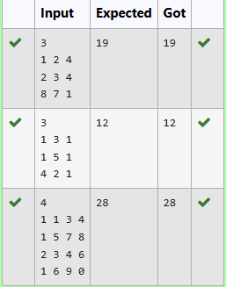

|  |  |
| --- | --- |
| **EXP.NO:5(c)** | **LONGEST COMMON SUBSEQUENCE** |
| **DATE:** |

**QUESTION:**

Given two strings find the length of the common longest subsequence(need not be contiguous) between the two.

Example: s1: ggtabe s2: tgatasb

|  |  |  |  |  |  |  |  |
| --- | --- | --- | --- | --- | --- | --- | --- |
| s1 | a | g | g | t | a | b |  |
| s2 | g | x | t | x | a | y | b |

The length is 4

Solveing it using Dynamic Programming

**PROGRAM:**

#include <stdio.h> #include <string.h>

int longest_common_subsequence(char s1[], char s2[]) { int m = strlen(s1);

int n = strlen(s2);

int dp[m + 1][n + 1];

for (int i = 0; i <= m; i++) { for (int j = 0; j <= n; j++) {

if (i == 0 || j == 0) { dp[i][j] = 0;

} else if (s1[i - 1] == s2[j - 1]) {

dp[i][j] = dp[i - 1][j - 1] + 1;} else {

dp[i][j] = (dp[i - 1][j] > dp[i][j - 1]) ? dp[i - 1][j] : dp[i][j - 1];

}

}

}

return dp[m][n];

}

int main() {

char s1[100], s2[100]; scanf("%s", s1);

scanf("%s", s2);

int result = longest_common_subsequence(s1, s2); printf("%d",result);

return 0;

}

**OUTPUT**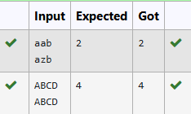

|  |  |
| --- | --- |
| **EXP.NO:5(d)** | **LONGEST NON-DECREASING SUBSEQUENCE** |
| **DATE:** |

**QUESTION:**

Problem statement:

Find the length of the Longest Non-decreasing Subsequence in a given Sequence. Eg:

Input:9

Sequence:[-1,3,4,5,2,2,2,2,3]

the subsequence is [-1,2,2,2,2,3] Output:6

**PROGRAM:**

#include <stdio.h>

int longest_non_decreasing_subsequence(int arr[], int n) { int dp[n];

int max_length = 1;

for (int i = 0; i < n; i++) { dp[i] = 1;

}

for (int i = 1; i < n; i++) { for (int j = 0; j < i; j++) {

if (arr[j] <= arr[i]) {

dp[i] = (dp[i] > dp[j] + 1) ? dp[i] : dp[j] + 1;}} if (dp[i] > max_length) {

max_length = dp[i];

}

}

return max_length;

}

int main() {

int n; scanf("%d", &n); int arr[n];

for (int i = 0; i < n; i++) { scanf("%d", &arr[i]); }

int result = longest_non_decreasing_subsequence(arr, n); printf( "%d\n", result);

return 0;

}

**OUTPUT:**

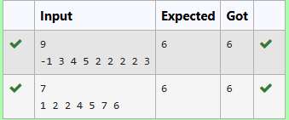

|  |  |
| --- | --- |
| **EXP.NO:6(a)** | **FINDING DUPLICATES-O(N^2) TIME COMPLEXITY,O(1) SPACE COMPLEXITY** |
| **DATE:** |

**QUESTION:**

Find Duplicate in Array.

Given a read only array of n integers between 1 and n, find one number that repeats. Input Format:

First Line - Number of elements n Lines - n Elements

Output Format:

Element x - That is repeated For example:

|  |  |
| --- | --- |
| Input | Result |
| 5  1 1 2 3 4 | 1 |

**PROGRAM:**

#include <stdio.h>

int findDuplicate(int arr[], int n) { int slow = arr[0];

int fast = arr[arr[0]]; while (slow != fast) { slow = arr[slow];

fast = arr[arr[fast]];

}

fast = 0;

while (slow != fast) { slow = arr[slow]; fast = arr[fast];

}

return slow;

}

int main() { int n;

scanf("%d", &n); int arr[n];

for (int i = 0; i < n; i++) { scanf("%d", &arr[i]);

}

int duplicate = findDuplicate(arr, n); printf("%d", duplicate);

return 0;

}

**OUTPUT:**

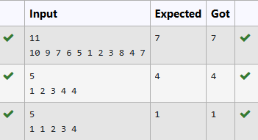

|  |  |
| --- | --- |
| **EXP.NO:6(b)** | **FINDING DUPLICATES-O(N) TIME COMPLEXITY,O(1) SPACE COMPLEXITY** |
| **DATE:** |

**QUESTION:**

Find Duplicate in Array.

Given a read only array of n integers between 1 and n, find one number that repeats. Input Format:

First Line - Number of elements n Lines - n Elements

Output Format:

Element x - That is repeated For example:

|  |  |
| --- | --- |
| Input | Result |
| 5  1 1 2 3 4 | 1 |

**PROGRAM:**

#include <stdio.h>

int findDuplicate(int arr[], int n) { int slow = arr[0];

int fast = arr[arr[0]]; while (slow != fast) { slow = arr[slow];

fast = arr[arr[fast]];

}

fast = 0;

while (slow != fast) { slow = arr[slow]; fast = arr[fast];

}

return slow;

}

int main() { int n;

scanf("%d", &n); int arr[n];

for (int i = 0; i < n; i++) { scanf("%d", &arr[i]);

}

int duplicate = findDuplicate(arr, n); printf("%d", duplicate);

return 0;

}

**OUTPUT:**

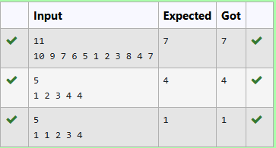

|  |  |
| --- | --- |
| **EXP.NO:6(c)** | **PRINT INTERSECTION OF 2 SORTED ARRAYS-O(M+N)TIME COMPLEXITY,O(1) SPACE COMPLEXITY** |
| **DATE:** |

**QUESTION:**

Find the intersection of two sorted arrays. OR in other words,

Given 2 sorted arrays, find all the elements which occur in both the arrays. Input Format

· The first line contains T, the number of test cases. Following T lines contain:

1. Line 1 contains N1, followed by N1 integers of the first array
2. Line 2 contains N2, followed by N2 integers of the second array Output Format

The intersection of the arrays in a single line Example

Input:

1

3 10 17 57

6 2 7 10 15 57 246

Output:

10 57

Input:

1

6 1 2 3 4 5 6

2 1 6

Output:

1 6

For example:

|  |  |
| --- | --- |
| Input | Result |
| 1  3 10 17 57 | 10 57 |

|  |  |
| --- | --- |
| Input | Result |
| 6  2 7 10 15 57 246 |  |

**PROGRAM:**

#include <stdio.h>

void findIntersection(int arr1[], int n1, int arr2[], int n2) { int i = 0, j = 0;

while (i < n1 && j < n2) { if (arr1[i] < arr2[j]) {

i++;

} else if (arr2[j] < arr1[i]) { j++;

} else {

printf("%d ", arr1[i]); i++;

j++;

}

}

printf("\n");

}

int main() { int T;

scanf("%d", &T);

while (T--) { int n1, n2;

scanf("%d", &n1); int arr1[n1];

for (int i = 0; i < n1; i++) { scanf("%d", &arr1[i]);

}

scanf("%d", &n2); int arr2[n2];

for (int i = 0; i < n2; i++) { scanf("%d", &arr2[i]);

}

findIntersection(arr1, n1, arr2, n2);

}

return 0;

}

**OUTPUT:**

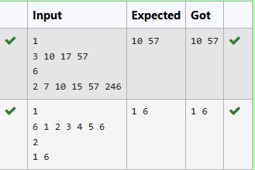

|  |  |
| --- | --- |
| **EXP.NO:6(d)** | **PRINT INTERSECTION OF 2 SORTED ARRAYS-O(M+N)TIME COMPLEXITY,O(1) SPACE COMPLEXITY** |
| **DATE:** |

**QUESTION:**

Find the intersection of two sorted arrays. OR in other words,

Given 2 sorted arrays, find all the elements which occur in both the arrays. Input Format

· The first line contains T, the number of test cases. Following T lines contain:

1. Line 1 contains N1, followed by N1 integers of the first array
2. Line 2 contains N2, followed by N2 integers of the second array Output Format

The intersection of the arrays in a single line Example

Input:

1

3 10 17 57

6 2 7 10 15 57 246

Output:

10 57

Input:

1

6 1 2 3 4 5 6

2 1 6

Output:

1 6

**For example:**

|  |  |
| --- | --- |
| **Input** | **Result** |
| 1 | 10 57 |

|  |  |
| --- | --- |
| **Input** | **Result** |
| 3 10 17 57  6  2 7 10 15 57 246 |  |

**PROGRAM:**

#include <stdio.h>

void findIntersection(int arr1[], int n1, int arr2[], int n2) { int i = 0, j = 0;

int found = 0;

while (i < n1 && j < n2) { if (arr1[i] < arr2[j]) {

i++;

} else if (arr2[j] < arr1[i]) { j++;

} else {

printf("%d ", arr1[i]); found = 1;

i++; j++;

}

}

if (!found) {

printf("No Intersection");

}printf("\n");

}

int main() { int T;

scanf("%d", &T);

while (T--) { int n1, n2;

scanf("%d", &n1); int arr1[n1];

for (int i = 0; i < n1; i++) { scanf("%d", &arr1[i]);

}

scanf("%d", &n2); int arr2[n2];

for (int i = 0; i < n2; i++) { scanf("%d", &arr2[i]);

}

findIntersection(arr1, n1, arr2, n2);

}

return 0;

}

**OUTPUT:**

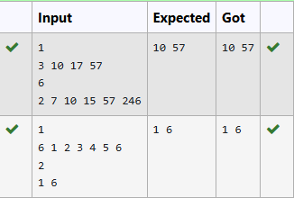

|  |  |
| --- | --- |
| **EXP.NO:6(e)** | **PAIR WITH DIFFERENCE-O(N^2)TIME COMPLEXITY,O(1) SPACE COMPLEXITY** |
| **DATE:** |

**QUESTION:**

Given an array A of sorted integers and another non negative integer k, find if there exists 2 indices i and j such that A[j] - A[i] = k, i != j.

Input Format:

First Line n - Number of elements in an array Next n Lines - N elements in the array

k - Non - Negative Integer Output Format:

1 - If pair exists

0 - If no pair exists

Explanation for the given Sample Testcase: YES as 5 - 1 = 4

So Return 1.

**For example:**

|  |  |
| --- | --- |
| **Input** | **Result** |
| 3  1 3 5  4 | 1 |

**PROGRAM:**

#include <stdio.h>

int findPairWithDifference(int arr[], int n, int k) { int i = 0, j = 1;

while (i < n && j < n) {

int diff = arr[j] - arr[i]; if (i != j && diff == k) {

return 1;

}

else if (diff < k) { j++;

}

else {

i++;

}

}

return 0;

}

int main() { int n, k;

scanf("%d", &n); int arr[n];

for (int i = 0; i < n; i++) { scanf("%d", &arr[i]);

}

scanf("%d", &k);

int result = findPairWithDifference(arr, n, k); printf("%d\n", result);

return 0;

}

**OUTPUT:**

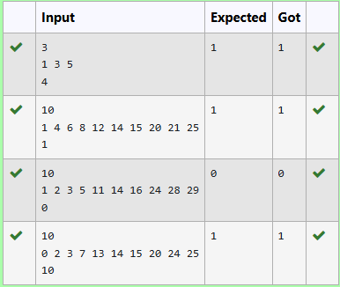

|  |  |
| --- | --- |
| **EXP.NO:6(f)** | **LONGEST NON-DECREASING SUBSEQUENCE** |
| **DATE:** |

**QUESTION:**

Given an array A of sorted integers and another non negative integer k, find if there exists 2 indices i and j such that A[j] - A[i] = k, i != j.

Input Format:

First Line n - Number of elements in an array Next n Lines - N elements in the array

k - Non - Negative Integer Output Format:

1 - If pair exists

0 - If no pair exists

Explanation for the given Sample Testcase: YES as 5 - 1 = 4

So Return 1. For example:

|  |  |
| --- | --- |
| Input | Result |
| 3  1 3 5  4 | 1 |

**PROGRAM:**

#include <stdio.h>

int findPairWithDifference(int arr[], int n, int k) { int i = 0, j = 1;

while (j < n) {

int diff = arr[j] - arr[i]; if (i != j && diff == k) {

return 1;

}

else if (diff < k) { j++;

}

else {

i++;

if (i == j) { j++;

}

}

}

return 0;

}

int main() { int n, k;

scanf("%d", &n); int arr[n];

for (int i = 0; i < n; i++) { scanf("%d", &arr[i]);

}

scanf("%d", &k);

int result = findPairWithDifference(arr, n, k); printf("%d\n", result);

return 0;

}

**OUTPUT:**

